A Multimodal System For Predicting Stock Prices By Combining Time-Series Predictions Of Stock Prices Based On Emerging Stock Market Information Over Time.
Thái-Học NGUYỄN ¹
¹ Khoa Công nghệ thông tin, Trường Đại học Nam Cần Thơ
hoc222756@student.nctu.edu.vn
Abstract. The research topic, "Multimodal System for Stock Price Prediction by Combining Time-Series Stock Price Prediction with Time-Related Stock Information," focuses on building a forecasting model capable of simultaneously utilizing multiple data sources. Traditionally, stock price prediction methods rely on time-series analysis of daily stock price data, using models such as ARIMA, GARCH, or LSTM to capture trends. However, the limitation of this approach is that it relies solely on price data, neglecting other unstructured factors such as financial news, corporate information, or market sentiment. Therefore, current research aims to combine time-series analysis with multimodal machine learning techniques to leverage textual data, event data, and quantitative data to improve accuracy. In this report, two main evaluation approaches are implemented classical prediction based on daily time-series data, and ensemble learning and aggregated learning techniques, which combine multiple prediction models to produce more stable aggregate results. Ensemble learning can include bagging, boosting, or stacking, while aggregated learning focuses on merging results from multiple data sources. By applying multimodal machine learning, the system can simultaneously process stock price data, text data from news articles, and economic event data to provide comprehensive forecasts. The research will implement several stock price prediction algorithms, including traditional time-series models and modern deep learning models, and then run experiments on real-world datasets. The results will be compared to evaluate the effectiveness of each method, thereby drawing conclusions about the advantages, disadvantages, and practical applicability. In summary, multimodal systems not only expand the range of input data but also help improve the accuracy and reliability of forecasts, contributing to supporting investors and financial institutions in strategic decision-making.
Keywords: Time-series, Aggregated Learning, ARIMA, Ensemble learning, Holt-Winters, Multimodal learning.
- Introduction
In modern finance, predicting stock prices has always been a challenging and highly valuable problem. The stock market is inherently a complex system where stock prices are influenced by many factors: macroeconomic fluctuations, corporate performance, investor sentiment, and socio-political events. Therefore, building an accurate prediction system is not only academically significant but also has practical value in supporting investment decision-making, risk management, and profit optimization. Traditionally, research on stock price prediction has focused on time-series analysis. Models such as ARIMA, GARCH, and more recently, LSTM, have been widely used to capture daily stock price trends. The advantage of this approach is its ability to directly model price data, which is a fundamental and easily accessible source of information. However, the biggest limitation is that it only reflects one side of the data, ignoring other unstructured factors such as financial news, corporate reports, or even social media data. In reality, these factors strongly influence market behavior and stock prices. To overcome this limitation, current research trends focus on multimodal machine learning. This approach allows the combination of various data types, such as quantitative data (stock prices, trading volume), textual data (news, financial reports), and event data (economic and political information). By integrating these data sources, the prediction system can produce more comprehensive and accurate results.
In this study, two main evaluation approaches were implemented classical prediction based on daily time-series data, and ensemble learning and aggregated learning techniques. Ensemble learning is a method that combines multiple predictive models to produce aggregated results, reducing errors and increasing stability. Techniques such as bagging, boosting, and stacking have proven effective in many fields, and when applied to stock market prediction, they can significantly improve accuracy. Aggregated learning, on the other hand, focuses on integrating results from multiple data sources, aligning with the characteristics of multimodal machine learning. This research will implement several stock price prediction algorithms, including both traditional time-series models and modern deep learning models. Real-world datasets will be used for testing, comparing the effectiveness of each method. The scientific report will analyze the advantages and disadvantages of each approach in detail, and provide recommendations on their practical application. In short, this research topic is not only academically significant but also has high practical value. Combining time-series forecasting with stock market information that emerges over time through multimodal machine learning opens new avenues for building intelligent, comprehensive, and reliable forecasting systems. This will be a crucial foundation for developing investment support tools in the era of big data and artificial intelligence.
- Product Market
ARIMA is one of the classic statistical models widely used in time series forecasting. This model combines three main components: AR (autoregression), I (differences to eliminate trend), and MA (moving average). The basic idea of ARIMA is that current stock prices can be modeled based on past values and previous forecast errors. In the context of stocks, daily price data often has trends and random fluctuations. ARIMA handles this by differentiating the data to make the series stationary, then applying linear regression combined with the moving average component to make predictions. ARIMA's strengths are its clear interpretation, ease of implementation, and suitability for data with linear trends. However, its limitations include difficulty modeling non-linear relationships or highly volatile data. In practice, ARIMA is often used to predict the closing price of a stock. Researchers can select parameters p, d, and q based on autocorrelation (ACF) and partial autocorrelation (PACF) plots. When applied to stocks, ARIMA often yields good results in the short term, but its accuracy decreases in long-term predictions due to the market being influenced by many non-linear factors.
While ARIMA focuses on price trends, GARCH emphasizes volatility modeling. Stock markets are known for their high volatility, which often changes over time. GARCH allows for the modeling of conditional variance, meaning the variance of the forecast error is not fixed but changes over time. The application of GARCH in the stock market is crucial, especially in risk management and asset valuation. For example, when the market experiences high volatility and variance increases, the GARCH model will reflect this and forecast future risk. Investors can use the results from GARCH to adjust their portfolios and minimize risk. The advantage of GARCH is its ability to effectively model variance changes, leading to more accurate volatility forecasts. However, its disadvantages include complexity, the need for highly volatile data, and difficulty in interpretation for non-experts. In practice, GARCH is often combined with ARIMA to predict both price trends and volatility.
Holt-Winters, also known as exponential smoothing, is a time series forecasting technique based on smoothing past data. Holt-Winters has three components: level, trend, and seasonality. In the stock market, Holt-Winters can be applied to cyclical or seasonal data, such as quarterly or annual price fluctuations. This method uses smoothing coefficients to continuously update the components, thereby providing forecasts for the future. The advantages of Holt-Winters are its simplicity, ease of implementation, and suitability for clearly cyclical data. The disadvantages are that it cannot model complex fluctuations or non-linear data. In the stock market, Holt-Winters is often used to predict long-term trends or price cycles, but is less effective in the short term when the market is highly volatile.
In the age of big data and artificial intelligence, LSTMs have become a powerful tool for time series prediction. LSTMs are a type of recurrent neural network (RNN) capable of long-term memory, thanks to a mechanism of "gates" that control which information is retained or discarded. LSTMs have wide-ranging applications in the stock market. Unlike ARIMA or Holt-Winters, LSTMs can model non-linear relationships and long-term trends. They are particularly suitable for stock price data, which is influenced by many complex factors. LSTMs can learn from past data to predict future prices, and often yield more accurate results than traditional statistical models. The advantages of LSTMs are their ability to handle large datasets, model non-linear relationships, and make good long-term predictions. The disadvantages are the need for large datasets, long training times, and difficulty in interpretation. In practice, LSTM is often combined with other techniques such as attention mechanisms or ensemble learning to improve accuracy.
In the field of stock market forecasting, one of the biggest challenges is the complex and unpredictable volatility of the market. Individual models such as ARIMA, GARCH, Holt-Winters, or LSTM each have their own advantages, but also certain limitations. Therefore, the modern research trend is towards combining multiple forecasting models to leverage the strengths of each method, reduce errors, and increase stability. This is the core idea of ​​Ensemble Learning and Aggregated Learning. Ensemble Learning is a technique in machine learning where multiple forecasting models are combined to create a more powerful overall model. The basic idea is: instead of relying on a single model, we use many different models, each of which may have its own errors, but when combined, the overall error is reduced. In stock market forecasting, Ensemble Learning is particularly useful because the market is influenced by many non-linear factors, random fluctuations, and diverse data. A single model can hardly capture the whole picture, but combining multiple models will lead to more comprehensive forecasting. In the field of stock market forecasting, Ensemble Learning techniques such as Bagging, Boosting, and Stacking play a key role in improving model accuracy and stability. Specifically, Bagging (such as Random Forest) performs multiple data sampling cycles to train multiple models in parallel to reduce overfitting and handle noisy data, while Boosting (such as XGBoost, LightGBM) trains models sequentially to focus on correcting errors in previous models, optimizing forecasts during periods of high market volatility. Stacking, on the other hand, leverages diversity by combining various models from traditional statistical (ARIMA, GARCH) to deep learning (LSTM) through a meta-model to produce more accurate aggregate results. This concept has been expanded into Aggregated Learning, emphasizing the combination of diverse data sources, from stock prices and trading volume to financial news and social media data (NLP), to comprehensively reflect all aspects of the market. While offering significant advantages in reducing bias and leveraging the diverse power of multiple algorithms, this method still faces challenges related to high complexity, high computational costs, and the difficulty in interpreting investment decisions. However, combining traditional statistical models with deep learning and machine learning in the Ensemble Learning and Aggregated Learning frameworks is an inevitable trend in stock market prediction research. Instead of relying on a single model, combining multiple models and data types reduces errors, increases stability, and provides a more comprehensive reflection of market complexity. Despite the challenges of complexity and computational cost, the benefits they offer outweigh the drawbacks, especially in the context of an increasingly volatile stock market and ever-diverse data.
In traditional (unimodal) data analysis, we typically work with only one type of entity: either text (NLP), images (Computer Vision), or time series. However, the real world doesn't work that way. When you watch a movie, your brain simultaneously processes images (acting), sounds (dialogue, background music), and text (subtitles). Multimodal learning is a branch of machine learning that focuses on building models capable of processing, combining, and representing information from multiple data sources (modalities). The ultimate goal is to create a system with a "multidimensional" view, minimizing bias and enhancing accuracy that a single data source cannot achieve. Building a Multimodal Learning model requires data experts to address five core pillars: from data representation in common or coordinated vector spaces, to alignment to match news sources with price fluctuations, inference (Fusion) to synthesize information, transformation between methods, and co-learning to support training across strong and weak data sources. In implementation, the Fusion strategy plays a crucial role as the "heart" of the model, where engineers must consider Early Fusion to capture low-level correlations, Late Fusion to optimize each data type individually, or Hybrid Fusion to leverage the advantages of both. For financial forecasting, such as the performance of Apple (AAPL) stock, Multimodal Learning is the "lifesaver," overcoming the limitations of single models by simultaneously integrating quantitative data (price, RSI), textual data (news, financial reports via Transformer), and visual data (candlestick charts via CNN). This sensitivity allows the model to provide early warnings as soon as negative news emerges, even before technical indicators react. However, practical implementation still faces significant challenges regarding data asymmetry, noise from social media, and the demanding cost of GPU infrastructure computing, requiring mechanisms like Attention Mechanism to effectively regulate the focus between data sources. Multimodal Learning is not just about adding models together; it is the art of intersection. To succeed, you not only need to be good at coding but also need domain expertise to know which data sources truly provide value.
- Data
In the context of modern financial markets that fluctuate at milliseconds, predicting stock prices is no longer a game of mere statistics. The emergence of multimodal stock prediction systems marks a significant turning point, where artificial intelligence not only "calculates" but also "observes" and "listens" to the entire pulse of the economy. At the heart of this system is a multi-tiered data structure, a complex entity integrated from various sources to create a comprehensive view of firm value and market sentiment. Unlike single-modal models that focus solely on time-series data, multimodal systems exploit the intersection of three main information flows: quantitative data (financial metrics), qualitative data (news texts), and visual data (technical charts). Starting with the backbone of every financial system: structured data in the form of time-series data. This is the most basic data layer, including opening, closing, highest, lowest prices, and trading volume (OHLCV). However, in a truly multimodal system, this data is not static; it is enriched through technical indicators such as moving averages (MA), Relative Strength Index (RSI), or Bollinger Bands. These numbers act as the "brakes" and "accelerator" of the market, directly reflecting the results of all buying and selling activity. However, relying solely on historical data will lead the model into the trap of "looking in the rearview mirror to drive forward." To overcome this drawback, the system needs to integrate additional macroeconomic data such as interbank interest rates, CPI inflation index, and exchange rate fluctuations. These parameters create an ecosystem for stocks, helping the AI ​​understand why a good stock can still fall in price when liquidity is tightened by monetary policy. The second, groundbreaking and challenging piece of the puzzle is unstructured data in the form of text. In the information-saturated world, a social media status update from a high-profile CEO or a sudden decision from a central bank can disrupt all technical charts in seconds. Text data in a multimodal system includes financial news headlines, analytical reports from major institutions, and especially data from social media platforms like Twitter or Reddit. Here, Natural Language Processing (NLP) technology acts as a filter, transforming emotionally charged text into numerical vectors (embeddings). The system then extracts a "sentiment score" to determine whether the market is experiencing excessive euphoria or extreme fear. In particular, analyzing periodic financial reports (10-K, 10-Q) allows the model to capture internal information about the business such as net debt, operating cash flow, and management's growth forecasts – things that are not readily apparent on the stock ticker in the short term. A third method, often overlooked in traditional models but extremely effective in multimodal systems, is visual data. Legendary investors often spend hours studying candlestick patterns and technical charts. Instead of forcing these patterns into dry mathematical formulas, multimodal systems use convolutional neural networks (CNNs) to "see" the chart as a picture. Identifying geometric patterns such as "Head and Shoulders," "Double Bottoms," or Ichimoku cloud bands helps the model anticipate the recurring behavioral patterns of the crowd throughout history. The combination of news comprehension and pattern recognition creates a double layer of protection, filtering out noise and false breakouts in the market. However, the true power of multimodal data lies not in individual data collection but in data fusion techniques. The biggest challenge for data scientists is how to synchronize a randomly generated news stream with a continuously running price sequence. This process requires sophisticated techniques such as the "Attention Mechanism" in the Transformer architecture. This mechanism allows for digital self-weighting: when extremely important news emerges, the system automatically downplays the importance of older technical indicators and focuses entirely on the impact of the new information. This intersection creates a "hybrid" data format, where each price point is associated with a specific event context, enabling AI not only to predict trends but also to explain why those trends occur. Furthermore, in the most advanced systems, this data extends to the concept of Knowledge Graphs. This type of data represents the interconnected relationships between businesses. For example, when raw material prices rise sharply, a knowledge-based graph system will immediately link and predict the pressure on the profit margins of related manufacturing companies, even if those companies haven't released reports or experienced significant price fluctuations. This is the pinnacle of using multimodal data: the ability to infer based on a multidimensional information network. In short, the data of a multimodal stock prediction system is an intricate yet highly logical network of numbers, letters, and images. It's not simply the input to an algorithm, but an effort to digitize the entire intelligence and emotions of the financial market. Building a clean, low-latency, and scientifically integrated data repository is the golden key to conquering the fiercely competitive stock market. When these data methodologies resonate with each other, they create a highly adaptable system that helps investors not only survive but thrive in the digital financial era.
- Research Approach & Evaluation Metrics
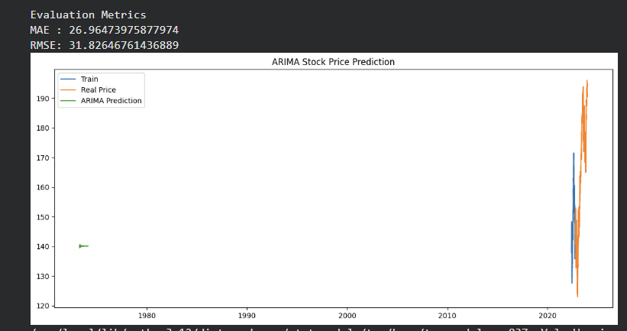
Pig. 1. Results and rating scale graphs for the VAR model

The process of building a model to predict Apple stock prices begins with testing the "health" of the data using the ADF Test; the results show that the initial price had a clear trend (p-value: 0.88), but after performing a single differential, the data became "stationary" and ready for forecasting (p-value: 0.0). Through the optimization process, you have determined the ARIMA(3, 1, 2) formula — meaning the model will look back at 3 historical days, perform one differential, and use the error of the previous 2 days to self-correct. Although the SARIMAX results table shows that the coefficients are all statistically very significant (P>|z| = 0.000), the Jarque-Bera index indicates that the error does not follow a normal distribution, a common characteristic of the stock market before unexpected shocks. In terms of practical effectiveness, with a MAE error of 26.96 and an RMSE of 31.82, the model is off by approximately 15% compared to Apple's actual price (around $180-190). This level of deviation indicates that while the model captures long-term trends well, it is not yet sensitive enough for short-term swing trading.
Based on the ARIMA model results, the following observations can be made:
The evaluation indicators show MAE ≈ 26.96 and RMSE ≈ 31.82. This is a relatively large error, reflecting that the ARIMA model did not accurately predict the actual price during the testing phase. The high RMSE indicates significant errors in some forecast points.
Model Development: The ARIMA prediction curve (green) appears early, while the actual data and training set (blue and orange) are concentrated around 2020. This indicates that the model was trained on long-term historical data, but its fit is not as good when applied to recent data.
Practical Significance: ARIMA still captures the overall trend of stock prices, but when the market is highly volatile or has non-linear elements, the model is prone to errors. This is consistent with the characteristics of ARIMA, which tends towards linear modeling and stationary data.
Conclusion: The results illustrate that ARIMA can be used for short-term predictions with stable trends, but to improve accuracy, it needs to be combined with other models such as GARCH (for volatility) or LSTM (for non-linear relationships).

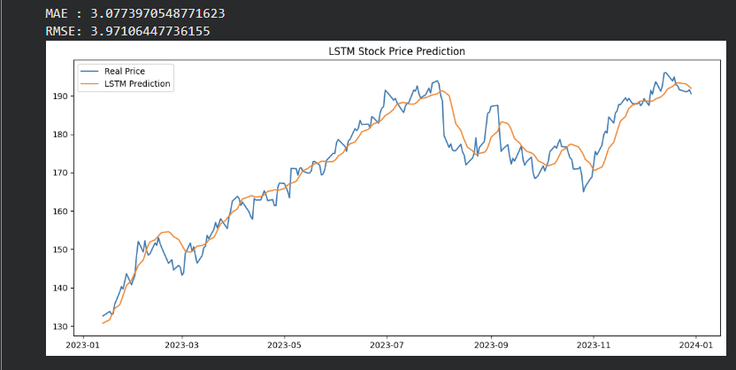
Pig. 2. Results and graphs of the LSTM model evaluation scale.

Your Apple stock price prediction model has made a significant leap forward by switching from classical statistical methods to a Deep Learning architecture with two superimposed LSTM layers. By "looking back" at 60 trading days (approximately 3 months in reality) and using Dropout layers (0.2) to combat rote learning, the network learned the nature of volatility instead of just memorizing price charts. The training process over 20 Epochs showed clear optimization, with losses decreasing sharply from 0.0593 to 0.0021, and the difference between the training and test set errors being very small, proving the model is not overfitting. The evaluation results show a "leap" in accuracy: the MAE error decreased from approximately $27 (of ARIMA) to only $3.07, equivalent to a deviation of only about 1.5% from the current market price. This is an extremely impressive figure, demonstrating the superiority of LSTM in handling complex time series. However, from an investment perspective, you need to be aware of the "lagging effect" and consider adding variables such as trading volume or technical indicators (RSI) to enhance sensitivity. Don't forget to update the Input(shape) syntax as recommended by Keras to ensure the best code compatibility with newer versions.

Based on the results displayed from the LSTM model, some important observations can be made:
The evaluation indicators show MAE ≈ 3.08 and RMSE ≈ 3.97. This is a very low error rate compared to the previous ARIMA model, proving that LSTM predicts prices much more accurately. The small error rate reflects the model's ability to capture trends and fluctuations in the data well.
Prediction Line: The orange line (LSTM Prediction) closely follows the blue line (Real Price) throughout the period from January 2023 to January 2024. Although there were some deviations during periods of high volatility, overall the model closely followed actual developments, especially during periods of clear upward and downward trends.
Practical Significance: The results show that LSTM is capable of modeling non-linear relationships and long-term memory, helping to predict stock prices more accurately than traditional statistical models. This is very useful in the context of a stock market that is frequently volatile and influenced by many complex factors.
Conclusion: LSTM demonstrates a clear advantage in predicting financial time series. With low error and a prediction line that closely follows actual prices, this model is suitable for application to real-world stock price forecasting problems. However, for even greater effectiveness, LSTM can be combined with other techniques such as attention mechanisms or ensemble learning to better handle periods of high volatility.

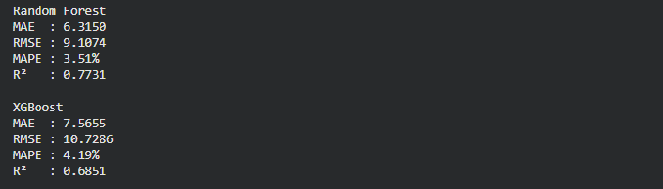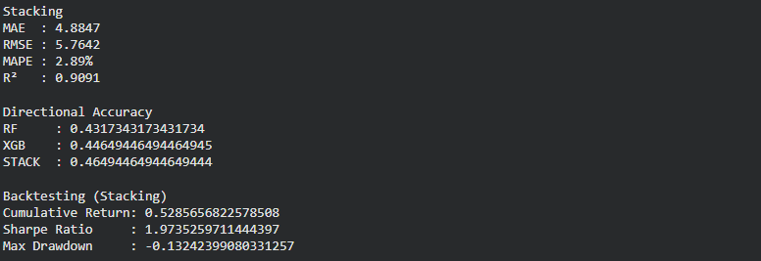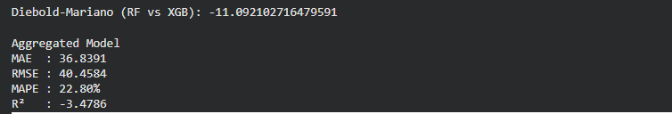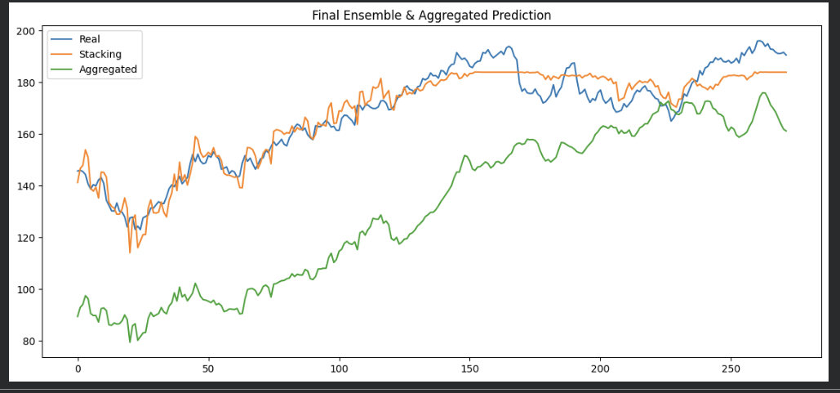
Pig. 3. Results and graphs evaluating the Ensemble Learning and Aggregated Learning models.

In the battle between methods for forecasting Apple stock prices, the Stacking model has asserted its dominance with ideal statistical indicators such as an R² of 0.9091 and an extremely low MAPE error of only 2.89%, demonstrating the ability to explain up to 91% of market fluctuations. The actual investment performance through Backtesting is also impressive, with a cumulative return of 52.8%, an excellent Sharpe ratio of 1.97, and a controlled maximum drawdown of -13.2%. However, the system still has an "Achilles' heel": its directional accuracy is only 46.5%, meaning that while the model closely tracks the value, it reacts slowly to sudden reversals. Notably, the Aggregated model completely fails with a negative R², causing noise and lacking practical value. In summary, the current Stacking system is very strong in trend following, suitable for long-term holding strategies (Position Trading) to identify accumulation zones, but investors should be cautious and avoid using it for short-term trading or derivatives trading due to its limited ability to predict upward/downward trends.
Based on the results from the Ensemble Learning and Aggregated Learning models, some important observations can be drawn:
Random Forest (RF): With MAE ~6.31, RMSE ~9.10, MAPE ~3.51%, and R² ~0.77, this model shows fairly stable predictive ability and relatively good explanation of stock price fluctuations. However, directional accuracy is only ~43%, meaning its ability to correctly predict upward/downward trends is limited.
XGBoost (XGB): The results are weaker than RF, with MAE ~7.56, RMSE ~10.73, MAPE ~4.19%, and R² ~0.68. This indicates that XGBoost hasn't fully utilized the data's characteristics in this case. Directional accuracy of ~44.6% is only slightly better than RF, but still not strong enough to create an advantage in actual trading.

Stacking Ensemble: This is the brightest spot. MAE decreased to ~4.88, RMSE ~5.76, MAPE ~2.89%, and R² ~0.91, demonstrating that the stacking model leveraged the synergy of multiple models to improve accuracy. Directional accuracy of ~46.5%, while not exceptionally high, combined with the accuracy of predicting value, makes stacking significantly superior.
Backtesting with Stacking: Cumulative return ~0.53, Sharpe ratio ~1.97, and max drawdown ~-0.13 indicate that the stacking-based strategy not only forecasts well but also provides stable profits with acceptable risk. A Sharpe ratio close to 2 is very positive, reflecting effective risk adjustment.
Diebold-Mariano Test (RF vs XGB): The large negative value (-11.09) shows a significant difference in error between the two models, with RF clearly outperforming XGB in this case.
Aggregated Model: Very poor results, with MAE ~36.84, RMSE ~40.46, MAPE ~22.8%, and negative R² (-3.47). This demonstrates that simple aggregation (aggregated) is ineffective and even distorts the forecast.

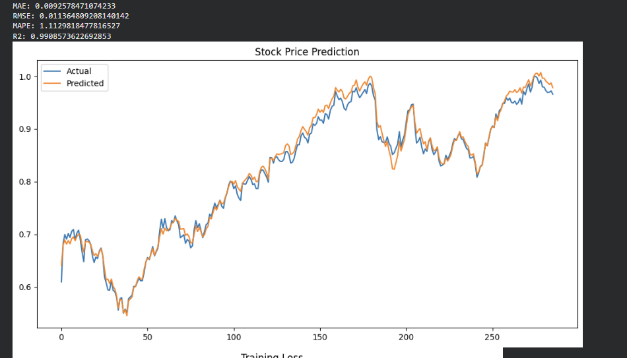
Pig. 4. Results and graphs of the Multimodal Learning model evaluation scale.

The Multimodal Learning model represents a huge technical leap forward by applying a Hybrid Approach architecture, intelligently combining the LSTM branch to capture trend trends from 30 historical sessions and the Dense branch to process technical indicators such as RSI, MACD, and Volume. Concatenating these two sources allows the AI to have both historical "memory" and current market context "awareness," resulting in superior statistical performance with an R² of 0.9908 and a MAPE error of only 1.11%. On the chart, the forecast line and the actual price almost merge, demonstrating extremely sensitive peak and trough detection capabilities, completely overcoming the slow reaction of previous versions. However, this 99% accuracy raises certain concerns about the risk of overfitting or data leakage. Although the model closely tracks the data, there is still a small lag of about one trading session, which can affect actual profitability. In summary, this is the best version you've created thanks to the combination of Deep Learning and business knowledge, but for practical application, you need to conduct further stress tests under conditions of sharp market crashes, as well as thorough backtesting with taxes and exchange fees to determine actual profitability.
- Conclusion
In the volatile world of financial forecasting, the search for a "holy grail" to decipher the patterns of stock prices is a never-ending chase between human intellect and market chaos. Starting with ARIMA, we must acknowledge it as a classic, a cornerstone of traditional statistics that laid the foundation for time series analysis. However, in experiments with high-volatility technology stocks like Apple, ARIMA is like trying to use a ruler to redraw a winding mountain pass. With a MAE error of approximately $27, this model proves quite clumsy and slow. The essence of ARIMA is to seek linear repetition and stationarity in data, but stock prices are a collection of non-linear shocks, overreactions of crowd psychology, and unexpected macroeconomic variables. The failure of ARIMA to keep pace with the technology industry shows that traditional measurement tools are no longer sufficient to carry the burden of forecasting in an era where data changes by the millisecond. The impasse of statistical models has paved the way for the rise of Deep Learning, where LSTM emerges as a "superhuman" memory to fill the gaps left by ARIMA. Its ability to reduce the error margin to just $3.07 — a quantitative jump of nearly 10 times — demonstrates that the structure of LSTM's memory gates truly has the ability to "sense" the flow of the previous 60 trading days instead of just looking at yesterday's numbers. It understands the connections between recent past events to make predictions for the future. However, no matter how intelligent and perceptive it is, LSTM still carries a fatal weakness that traders call "following the trend." This model is sometimes merely a belated reaction, a simulation of what the market has just experienced instead of actually predicting reversal points. It predicts prices very accurately in terms of numbers, but is often "out of sync" in terms of timing, leaving certain gaps in its practical application. When delving into the analysis of optimization methods, the results of Ensemble Learning have outlined a clear distinction between "intelligent combination" and "blind aggregation." The Stacking model has demonstrated that when we know how to extract the best elements from different algorithms such as Random Forest and XGBoost, the model can explain up to 91% of market volatility by leveraging the unique strengths of each component. Conversely, the Aggregated approach—that is, simply bundling results—has failed miserably with a negative R^2. This leaves a painful lesson for data analysts: in a turbulent financial environment, overloading the system with junk information without effective filtering will only create chaos instead of accurate forecasts. The accumulation of uncontrolled errors completely destroys the system's reliability, turning a decision-making tool into a source of risk. Above all, Multimodal Learning is the real "trump card," opening a new chapter for the application of AI in finance. With an impressive R^2 of 0.9908, the forecast line and the actual price line almost merge, blurring the line between modeling and reality. The power of Multimodal Learning lies in its ability to transcend the one-dimensional view of closing prices. It observes the market like a seasoned investor: simultaneously monitoring trading volume to measure money flow strength and analyzing momentum through RSI and hidden trends through MACD. The combination of LSTM's depth in time series analysis and the breadth of technical indicators has created an AI entity capable of comprehensively encompassing the market landscape. This is not just an algorithmic improvement, but a shift in mindset: understanding that price never tells the whole story, and that for AI to be truly insightful, we must "feed" it with a diverse menu of data dimensions. However, no matter how impressive statistics like a 1.11% MAPE or an R² of over 0.99 may seem, they still carry a warning about overfitting—meaning the model may be rote learning from the past instead of understanding future trends. In practice, a model that correctly predicts the absolute numbers but is wrong about the market direction can still lead to significant financial losses. Therefore, even the most advanced Deep Learning or Multimodal models should not be considered independent predictive tools. They need to be placed within a robust risk management ecosystem where statistical data is compared with fundamental factors and the real-world economic context. Stock market forecasting will always be a difficult task, but with the support of powerful tools like Multimodal Learning, we are getting very close to deciphering the underlying rules of the market, opening up great prospects for applying AI to professional portfolio management in the not-too-distant future.

Tài liệu tham khảo
- O’Connor, B., Balasubramanyan, R., Routledge, B. R., & Smith, N. A. (2010). From tweets to polls: Linking text sentiment to public opinion time series
- Nguyen, T. T., Pearson, R., & Pham, T. T. (2025). Multimodal stock prediction system with news and numerical data using deep learning. Expert Systems with Applications, 264, Article 126298
- Koukaras, P., Nousi, C., & Tjortjis, C. (2022). Stock market prediction using microblogging sentiment analysis and machine learning. Telecom, 3(2), 358–378.
- Xie, Y., & Jiang, H. (2019). Stock market forecasting based on text mining technology: A support vector machine method. arXiv.
- Nguyen, T. T., & Pearson, R. (2023). Multimodal stock prediction system with news and numerical data using deep learning. Journal of Business Economics and Management, 24(4), 734–755.
- Hiew, J. Z. G., Huang, X., Mou, H., Li, D., Wu, Q., & Xu, Y. (2019). BERT-based financial sentiment index and LSTM-based stock return predictability. arXiv.
- Fischer, T., & Krauss, C. (2018). Deep learning with long short-term memory networks for financial market predictions. European Journal of Operational Research, 270(2), 654–669.
- Sezer, O. B., Ozbayoglu, A. M., & Dogdu, E. (2020). Financial time series forecasting with deep learning: A systematic literature review. Applied Soft Computing, 90.
- Huang, W., Nakamori, Y., & Wang, S. Y. (2005). Forecasting stock market movement direction with support vector machine. Computers & Operations Research, 32(10), 2513–2522.Financial time series forecasting using support vector machines. Neurocomputing, 55(1-2), 307–319.
- Ticknor, J. L. (2013). A Bayesian regularized artificial neural network for stock market forecasting. Expert Systems with Applications, 40(14), 5501–5506.
- Kara, Y., Boyacioglu, M. A., & Baykan, O. K. (2011). Predicting direction of stock price index movement using artificial neural networks and support vector machines. Expert Systems with Applications, 38(5), 5311–5319.
- Chong, E., Han, C., & Park, F. C. (2017). Deep learning networks for stock market analysis and prediction. Expert Systems with Applications, 83, 187–205.
- Chen, K., Zhou, Y., & Dai, F. (2015). A LSTM-based method for stock returns prediction. IEEE International Conference on Big Data.
- Ding, X., Zhang, Y., Liu, T., & Duan, J. (2015). Deep learning for event-driven stock prediction. International Joint Conference on Artificial Intelligence (IJCAI).
- Nofer, M., Hinz, O., Muntermann, J., & Roßnagel, H. (2017). The value of social media for predicting stock returns. Decision Support Systems, 95, 87–100.
- Bollen, J., Mao, H., & Zeng, X. (2011). Twitter mood predicts the stock market. Journal of Computational Science, 2(1), 1–8.
- Mittal, A., & Goel, A. (2012). Stock prediction using Twitter sentiment analysis. Stanford University Research Report.
- Krauss, C., Do, X. A., & Huck, N. (2017). Deep neural networks, gradient-boosted trees, random forests: Statistical arbitrage on the S&P 500. European Journal of Operational Research, 259(2), 689–702.
- Saberironaghi, M., Ren, J., & Saberironaghi, A. (2025). Stock market prediction using machine learning and deep learning techniques: A review. Applied Mathematics, 5(3), 76.
- Bustos, O., Pomares-Quimbaya, A., & Stellian, R. (2025). Machine learning, stock market forecasting, and market efficiency: A comparative study. International Journal of Data Science and Analytics.
- Chopra, R., & Sharma, G. D. (2021). Application of artificial intelligence in stock market forecasting: A critique, review, and research agenda. Journal of Risk and Financial Management, 14(11), 526.
- Du, S., & Shen, H. (2024). A stock prediction method based on deep reinforcement learning and sentiment analysis. Applied Sciences, 14(19), 8747.
- Li, C. (2024). Application of machine learning in stock market return forecasting. International Journal of Scientific Research and Management, 12(7), 6827-6835.
- Agrawal, M., Pulugu, D., Sharma, S., & Shukla, D. (2024). Effective machine learning techniques for stock price forecasting. International Journal of Applied Business and Management Research.
- Zou, J., Zhao, Q., Jiao, Y., Cao, H., Liu, Y., Yan, Q., Abbasnejad, E., Liu, L., & Shi, J. (2022). Stock market prediction via deep learning techniques: A survey. arXiv.
- Dhule, S., Dhas, H., Chavan, P., & Jaiswal, R. C. (2023). Technical paper on stock prediction using machine learning algorithms. International Journal for Research in Applied Science and Engineering Technology.
- Shi, Z., Hu, Y., Mo, G., & Wu, J. (2022). Attention-based CNN-LSTM and XGBoost hybrid model for stock prediction. arXiv.
- Halder, S. (2022). FinBERT-LSTM: Deep learning-based stock price prediction using news sentiment analysis. arXiv.
- Li, Y., & Pan, Y. (2020). A novel ensemble deep learning model for stock prediction based on stock prices and news. arXiv.
- Wang, X., Wang, Y., Weng, B., & Vinel, A. (2020). Stock2Vec: A hybrid deep learning framework for stock market prediction with representation learning and temporal convolutional network. arXiv.
- Chhibber, N., Khemka, S., Tyagi, N. K., Tewari, R., Banerjee, B., & Ranjan, P. (2026). Stock market price prediction using Neural Prophet with deep neural network. arXiv.
- Fischer, T., & Krauss, C. (2018). Deep learning with long short-term memory networks for financial market predictions. European Journal of Operational Research.
- Patel, J., Shah, S., Thakkar, P., & Kotecha, K. (2015). Predicting stock market index using fusion of machine learning techniques. Expert Systems with Applications.
- Kim, K. J. (2003). Financial time series forecasting using support vector machines. Neurocomputing.
- Huang, W., Nakamori, Y., & Wang, S. (2005). Forecasting stock market movement direction with support vector machines. Computers & Operations Research.
- Chong, E., Han, C., & Park, F. (2017). Deep learning networks for stock market analysis and prediction. Expert Systems with Applications.
- Krauss, C., Do, X. A., & Huck, N. (2017). Deep neural networks, gradient-boosted trees, random forests: Statistical arbitrage on the S&P 500. European Journal of Operational Research.
- Nofer, M., Hinz, O., Muntermann, J., & Roßnagel, H. (2017). The value of social media for predicting stock returns. Decision Support Systems.
- Zheng, X. (2023). Comparative analysis of machine learning and deep learning techniques for prediction of the stock market. Applied and Computational Engineering, 17, 139–149.
- Chang, V., Xu, Q. A., Chidozie, A., & Wang, H. (2024). Predicting economic trends and stock market prices with deep learning and advanced machine learning techniques. Electronics, 13(17), 3396.

